**TIC TAC TOE**

**GAME**

**USING C**



**-Ramisetty Kumar**

**SBCS INDIA PVT LTD.**

**Contents:**

1.Introduction

- Purpose of the Document

- Project Overview

2.Flowchart

- Flowchart of Game Logic

3.Game Rules and Objectives

- Objective of the Game

- Game Components

- How to Win

- How to Play

4.Implementation Overview

- Programming Language

- Data Structures

- Game Logic

5.Code Explanation

- initialize_board()

- print_board()

- check_win(char player)

- is_board_full()

6.Conclusion

- Summary of the Project

- Future Improvements

7.References.

**1. Introduction**

Tic Tac Toe, also known as Noughts and Crosses, is a timeless and beloved game enjoyed by people of all ages. It's a classic two-player game that requires strategy, critical thinking, and a dash of luck. The game is deceptively simple, yet it offers endless possibilities and excitement with each move.

**Purpose of the Document:**

This document serves as a comprehensive guide and documentation for the Tic Tac Toe game implemented in the C programming language. It includes detailed explanations, a flowchart, and images to facilitate understanding.

**Project Overview:**

The Tic Tac Toe game is a classic two-player board game. The project aims to create a console-based version of the game, allowing two players to play on the same computer.

**2.Flowchart**

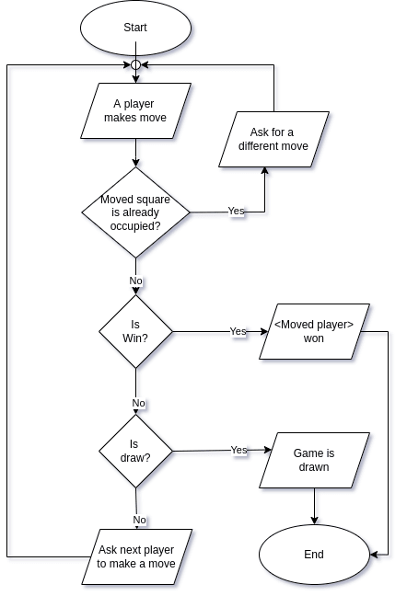

**3. Game Rules and Objectives**

**Objective of the Game:**

The objective is to be the first player to get three of their marks (X or Y) in a row, either horizontally, vertically, or diagonally, on a 3x3 grid.

**Game Components:**

Game Board: A 3x3 grid where players make their moves.

**How to Win:**

A player wins the game if they have three of their marks in a row, either horizontally, vertically, or diagonally.

**How to Play:**

Players take turns placing their marks on the board. The game continues until one player wins or the board is full, resulting in a draw.

**4. Implementation Overview**

**Programming Language:**

The game is implemented in the ‘C’ programming language.

**Data Structures:**

The game uses a 2D array to represent the game board and simple variables to manage player turns and input.

**Game Logic:**

The core game logic involves checking for a win after each move and determining if the game ends in a draw.

**5. Code Explanation**

In this section, you will find detailed explanations of key functions used in the game:

**initialize_board():**

This function initializes the game board by filling all cells with empty spaces (' ').

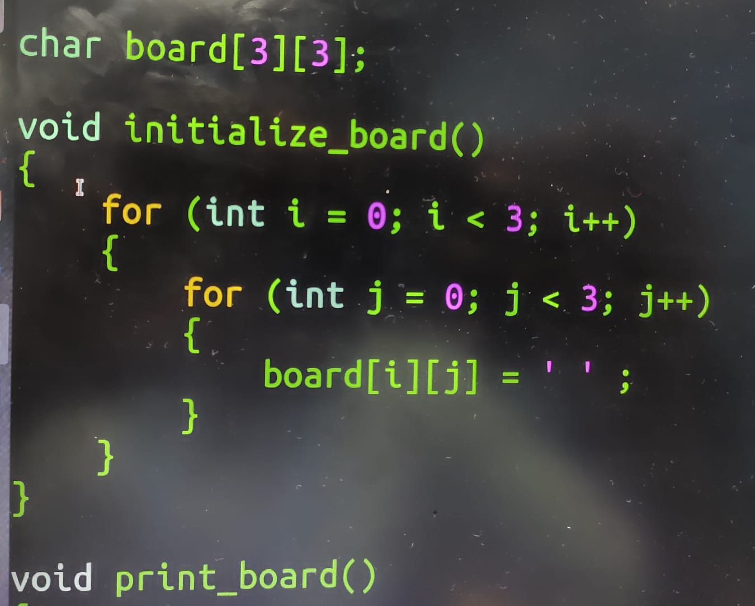

**print_board():**

The print_board() function displays the current state of the game board in a visually appealing format.

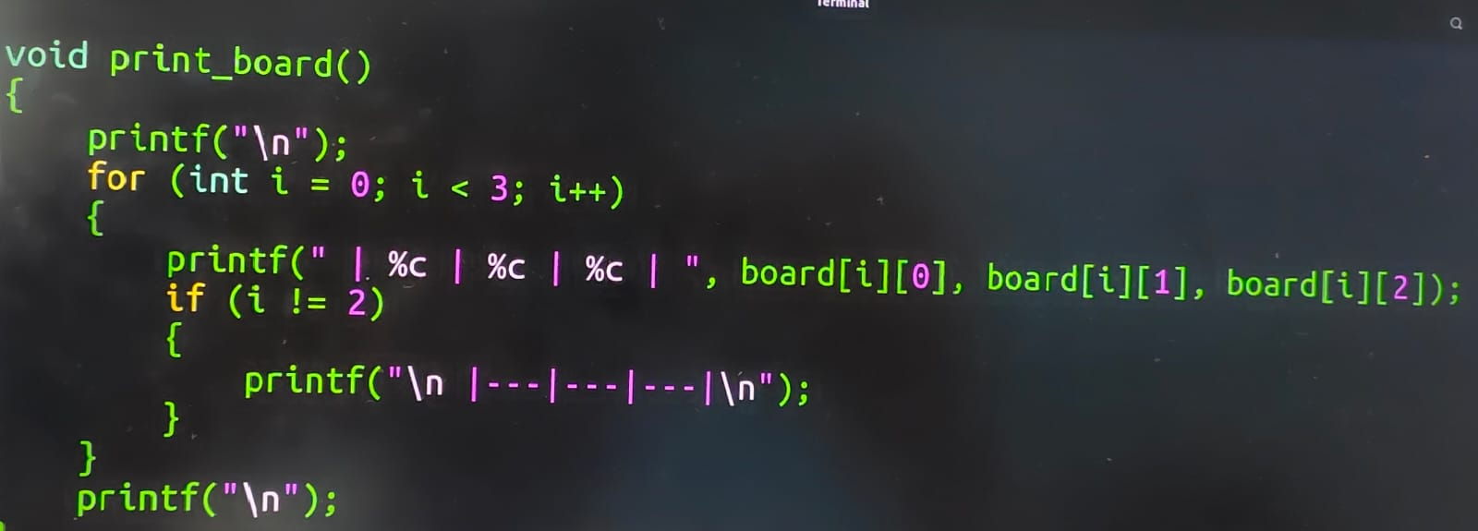

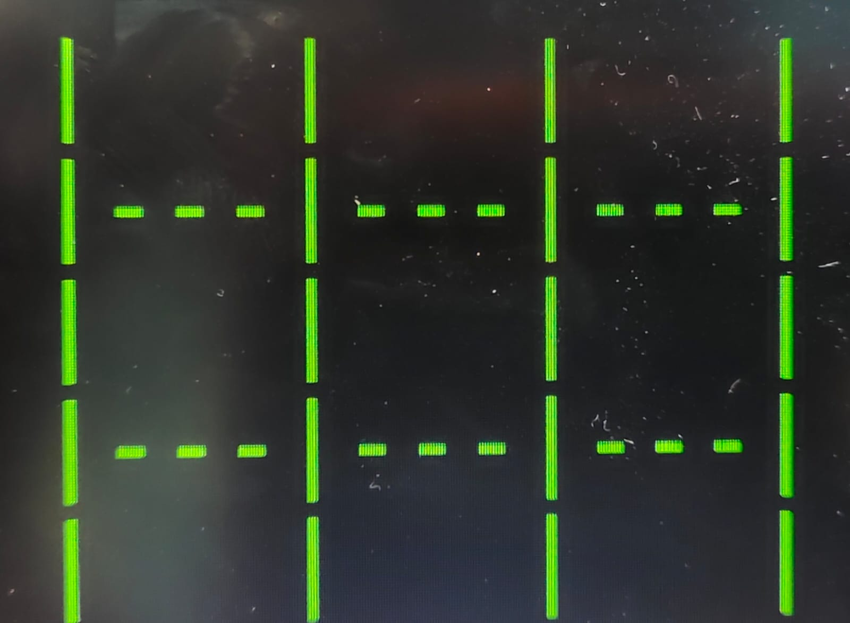

**check_win(char player):**

The check_win(char player) function checks if the specified player (X or Y) has won the game. It examines rows, columns, and diagonals to determine if the player has three marks in a row.

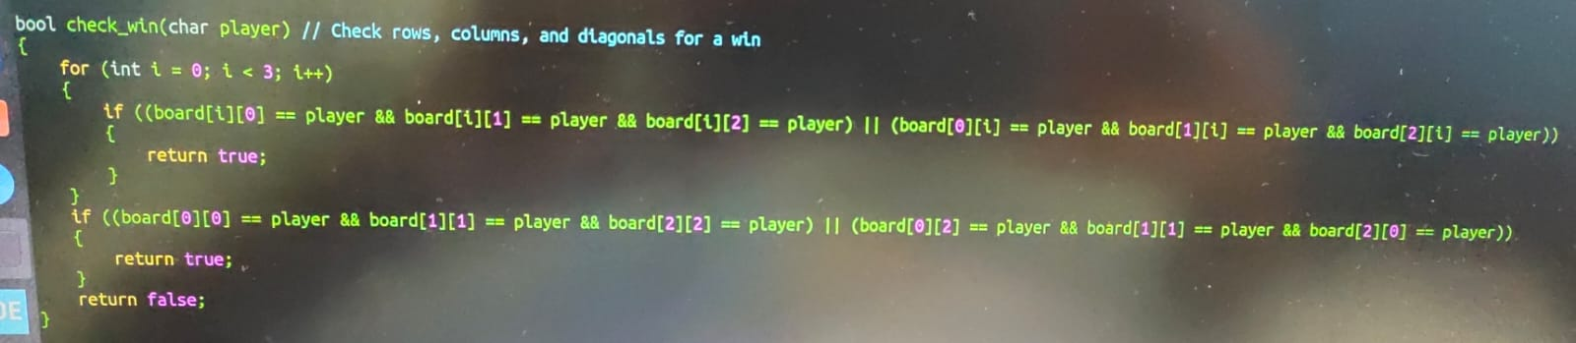

**is_board_full():**

The is_board_full() function checks if the game board is completely filled with marks. It iterates through the entire board and returns ‘true’ if there are no empty spaces left.

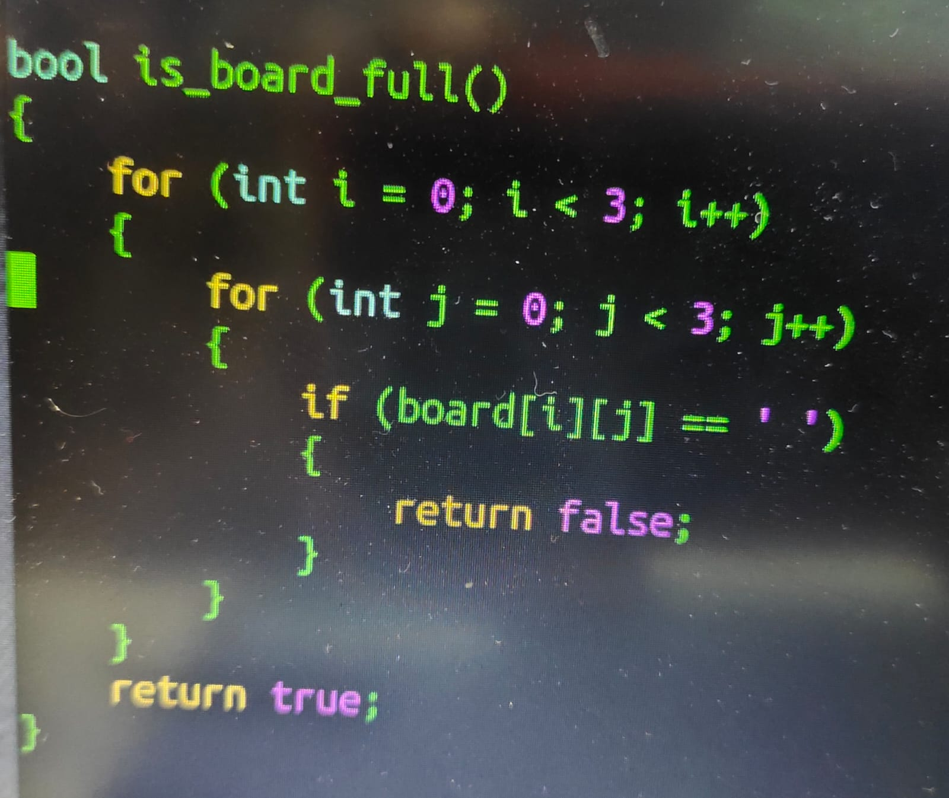

**6. Conclusion**

In this project,we successfully implemented a console-based Tic Tac Toe game in the C programming language.The primary objective was to recreate the classic board game experience in a digital format,allowing players to enjoy it conveniently on their computers

**User experience:**

Players can enjoy the timeless game of Tic Tac Toe on their computers with our user_friendly console interface.The game’s simple design and clear instructions make it accessible to players of all ages.

**7. Future Improvements**

1.Online Multiplayer Mode: Implement a server-client architecture that allows players to connect to a centralized game server over the internet.

2.Real-Time Gameplay: Enable real-time communication between players. Each player's moves are transmitted to the server and relayed to the opponent's computer, ensuring a synchronized gaming experience.

3.Enhanced Graphics: Transition from a console interface to a graphical user interface (GUI) with enhanced graphics and animations for a more visually appealing experience.

4.Voice Chat: Integrate voice chat capabilities to enable players to communicate during the game, adding a social dimension to the experience.

**8. References**

* [GitHub](https://github.com/): A widely-used platform for version control and collaboration on software projects.